

A

***Project Report***

On

***RESTURANT MENU SYSTEM***

For the Course

***(FOP LAB)***

***Fundamental of Program***

Submitted by

|  |  |  |
| --- | --- | --- |
| Name | Reg ID | Degree |
| Aman | 2012375 | BSCS |
| Mohammad Ali | 2012389 | BSCS |
| Hasnain Ali | 2012384 | BSCS |

Submitted to

|  |
| --- |
| *Ma’am Momal Rehman* |

Submission Date

|  |
| --- |
| *17-01-2021* |

**Abstract Page**

***Summary***

This program is about restaurant menu based on C language in which the customers can order his/her full meal. Main objective builds the system this is to provide ordering by online to the customers from their tables. And this will cut off the cost of waiters. With the online system ordering will become easier and systematic to replace traditional system where are still using papers and save the cost of paper. The order will take digitally. This system helps user a lot because user can easily order their meal form anywhere the home delivery option is available there.

***CONTENTS***

|  |  |
| --- | --- |
| *Chapters Name* | *Page No.* |
| Introduction | 2 |
| Algorithms and Flowcharts | 2-17 |
| Working of Project (With Screenshots) | 18-65 |
| Background and Problems | 66 |
| Conclusion | 66 |

***Chapter 1***

***Introduction***

The restaurant menu system is made for to provide service facility to restaurant and the customer, this application helps the restaurant to do all the functionalities more accurately and faster way. The traditional system is a restaurant paper menu and ordering system is replaced with an electronic medium like a digital system. Due to a digitalized system, the risk of manual errors is eliminated, thus eliminating the communication barrier. The system displays all the information of menu to the customer.

That is the main purpose of creating this system. The user can create an ID for this transaction. This will help consumers to get food deals and if the customer wants to order their own food, there is a home delivery system and when the customer enters the restaurant and will have a seat, he/she will place his order with the help of the touch screen using the application right from the selection of food till the payment confirmation. He/she will select from the food options according to his choice and the system will display the payment amount after that he/she will add the quantity if he/she wants.

***Chapter 2***

***Algorithm***

1. Start
2. Initialize functions of void dine(void), void delivery(void), void About(void), void bio(void), void adr(void), void menu(void), void star(void), void mainc(void), void desert(void), void beverages(void), void bill(void), void reset(void); void treset(void); void keys(void); void sign(void); void login(void); void deals(void);
3. Initialize variable int total, int qua, int choice, int key, int num
4. Initialize variable char name[100], char addr[100]
5. Initializing function void main(void)
6. Initializing variable int chk
7. Print “WELCOME TO LAZEEZ PAKWAAN :D”
8. Print “Enter your preference =>”
9. Print “1)Dine-In”
10. Print “2)Delivery.”
11. Print “3)About us.”
12. Print “4)Exit”
13. Take input chk
14. Implement switch (chk)
15. case 1:
16. print “You choose Dine-In"
17. Print “1)Sign-Up for Exclusive Deals:”
18. Print “2)Login to Get Exclusive Deals:”
19. Print “3)Normal Menu:”
20. Read chk
21. Implement switch
22. Case1:
23. Print “SIGN-UP”
24. sign();
25. login();
26. break;
27. case 2:
28. print "LOGIN";
29. login();
30. break;
31. Case 3:
32. menu();
33. break;
34. Default:
35. Print "Wrong Input."
36. keys();
37. break;
38. break;
39. case2:
40. print "You choose Delivery"
41. adr()
42. print addr
43. menu()
44. break
45. case 3:
46. print “About Us “
47. About()
48. Break
49. case 4:
50. print “ Thank you for using our service”
51. break
52. default:
53. print "Wrong Input"
54. print "press any number from 1 to 9 to return to home screen"
55. Take input key
56. if(key>=0 && key<=9)
57. main()
58. break
59. Initializing function void menu(void)
60. Initializing variable int chk
61. Print "What would you like to have?”
62. Print “1)Starters”
63. Print "2)Main Course"
64. Print "3)Desert "
65. Print "4)Beverages"
66. Print "5)Back to home screen and reset?"
67. Takes input chk
68. Implement switch(chk)
69. case 1:
70. print "Starters”
71. star()
72. break
73. case 2:
74. print "Main Course"
75. mainc()
76. break
77. case 3:
78. print "Deserts"
79. desert()
80. break
81. case 4:
82. print "Beverages"
83. beverages()
84. break
85. case 5:
86. reset()
87. main()
88. break
89. default:
90. print "Wrong Input"
91. Print "press any number from 1 to 9 to return to home screen”
92. Takes input key
93. if(key>=0 && key<=9)
94. main()
95. break
96. Initializing function void star(void)
97. Initializing variable int st
98. Print "1)Finger Fish and Fries 200rs "
99. Print "2)Paneer Tikka 300rs"
100. Print "3)Indian Onion Salad 200rs"
101. Print "4)Garlic Bread 250rs"
102. Print "5)Back to menu”
103. Takes input st
104. Implementing switch(st)
105. case 1:
106. Print qua
107. Takes input qua
108. total=total+200*(qua);
109. print "Enter your preference: "
110. print "1) Order Again   
     2)Get your total  
     3)reset your order"
111. Takes input choice
112. if(choice==1)
113. menu()
114. else if(choice==2)
115. bill()
116. else if(choice==3)
117. reset()
118. break
119. case 2:
120. print qua
121. Takes input qua
122. total=total+300*(qua)
123. print "Enter your preference:"
124. print "1) Order Again  
     2)Get your total  
     3)reset your order"
125. Takes input choice
126. if(choice==1)
127. menu()
128. else if(choice==2)
129. bill()
130. else if(choice==3)
131. reset()
132. break
133. case 3:
134. print qua
135. Takes input qua
136. total=total+200*(qua)
137. print "Enter your preference:"
138. print "1) Order Again  
     2)Get your total  
     3)reset your order"
139. Takes input choice
140. if(choice==1)
141. menu()
142. else if(choice==2)
143. bill()
144. else if(choice==3)
145. reset()
146. break
147. case 4:
148. print qua
149. Takes input qua
150. total=total+250*(qua)
151. print “Enter your preference: "
152. print "1) Order Again  
     2)Get your total  
     3)reset your order"
153. Takes input choice
154. if(choice==1)
155. menu()
156. else if(choice==2)
157. bill()
158. else if(choice==3)
159. reset()
160. break
161. case 5:
162. menu()
163. break
164. default:
165. print "Wrong input."
166. Print “press any number from 1 to 9 to return to home screen"
167. Takes input key
168. if(key>=0 && key<=9)
169. main()
170. break
171. Initializing void mainc(void)
172. Initializing variable st
173. Print "1)Biryani 400rs"
174. Print "2)Tandoori Chicken 1200rs”
175. Print "3)Malai Kofta 800rs”
176. Print "4)Chicken Kerhai 1000rs”
177. Print "5)Back to menu"
178. Takes input st
179. Implementing switch(st)
180. case 1:
181. print qua
182. Takes input qua
183. total=total+400*(qua)
184. print "Enter your preference:"
185. print “ 1) Order Again  
     2)Get your total   
     3)reset your order"
186. Takes input choice
187. if(choice==1)
188. menu()
189. else if(choice==2)
190. bill()
191. else if(choice==3)
192. reset()
193. break
194. case 2:
195. print qua
196. Takes input qua
197. total=total+1200*(qua)
198. print "Enter your preference:"
199. print "1) Order Again   
     2)Get your total  
     3)reset your order"
200. Takes input choice)
201. if(choice==1)
202. menu()
203. else if(choice==2)
204. bill()
205. else if(choice==3)
206. reset()
207. Break
208. case 3:
209. print qua
210. Takes input qua
211. total=total+800*(qua)
212. print "Enter your preference:"
213. print "1) Order Again   
     2)Get your total  
     3)reset your order"
214. Takes input choice
215. if(choice==1)
216. menu()
217. else if(choice==2)
218. bill()
219. else if(choice==3)
220. reset()
221. break
222. case 4:
223. Print qua
224. Takes input qua
225. total=total+1000*(qua)
226. Print "Enter your preference:"
227. Print "1) Order Again   
     2)Get your total   
     3)reset your order"
228. Takes input choice
229. if(choice==1)
230. menu()
231. else if(choice==2)
232. bill()
233. else if(choice==3)
234. reset()
235. break
236. case 5:
237. menu()
238. break
239. default:
240. Print "Wrong input."
241. Print "press any number from 1 to 9 to return to home screen"
242. Takes input key
243. if(key>=0 && key<=9)
244. main()
245. break
246. Initializing function void desert(void)
247. Initializing variable st
248. Print "1)Mint Oreo Cake 400rs"
249. Print "2)Brownies 400rs"
250. Print "3)Molten Chocolate Crackle Pie 550rs"
251. Print "4)Gulab Jamun 300rs"
252. Print "5)Back to menu"
253. Takes input st
254. Implementing switch(st)
255. case 1:
256. print qua
257. Takes input qua
258. total=total+400*(qua)
259. print "Enter your preference:"
260. print “ 1) Order Again  
     2)Get your total   
     3)reset your order"
261. Takes input choice
262. if(choice==1)
263. menu()
264. else if(choice==2)
265. bill()
266. else if(choice==3)
267. reset()
268. break
269. case 2:
270. print qua
271. Takes input qua
272. total=total+400*(qua)
273. print "Enter your preference:"
274. print "1) Order Again   
     2)Get your total  
     3)reset your order"
275. Takes input choice)
276. if(choice==1)
277. menu()
278. else if(choice==2)
279. bill()
280. else if(choice==3)
281. reset()
282. Break
283. case 3:
284. print qua
285. Takes input qua
286. total=total+550*(qua)
287. print "Enter your preference:"
288. print "1) Order Again   
     2)Get your total  
     3)reset your order"
289. Takes input choice
290. if(choice==1)
291. menu()
292. else if(choice==2)
293. bill()
294. else if(choice==3)
295. reset()
296. break
297. case 4:
298. Print qua
299. Takes input qua
300. total=total+300*(qua)
301. Print "Enter your preference:"
302. Print "1) Order Again   
     2)Get your total   
     3)reset your order"
303. Takes input choice
304. if(choice==1)
305. menu()
306. else if(choice==2)
307. bill()
308. else if(choice==3)
309. reset()
310. break
311. case 5:
312. menu()
313. break
314. default:
315. Print "Wrong input."
316. Print "press any number from 1 to 9 to return to home screen"
317. Takes input key
318. if(key>=0 && key<=9)
319. main()
320. break
321. Initializing function void beverages(void)
322. Initializing variable st
323. Print "1)Lamonade 100rs\n"
324. Print "2)Coffee 200rs\n"
325. Print "3)Hot Choclate 250rs\n"
326. Print "4)Cold Drinks 80rs\n"
327. Print "5)Back to menu\n"
328. Takes input st
329. Implementing switch(st)
330. case 1:
331. print qua
332. Takes input qua
333. total=total+100*(qua)
334. print "Enter your preference:"
335. print “ 1) Order Again  
     2)Get your total   
     3)reset your order"
336. Takes input choice
337. if(choice==1)
338. menu()
339. else if(choice==2)
340. bill()
341. else if(choice==3)
342. reset()
343. break
344. case 2:
345. print qua
346. Takes input qua
347. total=total+200*(qua)
348. print "Enter your preference:"
349. print "1) Order Again   
     2)Get your total  
     3)reset your order"
350. Takes input choice)
351. if(choice==1)
352. menu()
353. else if(choice==2)
354. bill()
355. else if(choice==3)
356. reset()
357. Break
358. case 3:
359. print qua
360. Takes input qua
361. total=total+250*(qua)
362. print "Enter your preference:"
363. print "1) Order Again   
     2)Get your total  
     3)reset your order"
364. Takes input choice
365. if(choice==1)
366. menu()
367. else if(choice==2)
368. bill()
369. else if(choice==3)
370. reset()
371. break
372. case 4:
373. Print qua
374. Takes input qua
375. total=total+80*(qua)
376. Print "Enter your preference:"
377. Print "1) Order Again   
     2)Get your total   
     3)reset your order"
378. Takes input choice
379. if(choice==1)
380. menu()
381. else if(choice==2)
382. bill()
383. else if(choice==3)
384. reset()
385. break
386. case 5:
387. menu()
388. break
389. default:
390. Print "Wrong input."
391. Print "press any number from 1 to 9 to return to home screen"
392. Takes input key
393. if(key>=0 && key<=9)
394. main()
395. break
396. Initializing function void bill(void)
397. Initializing variable float gtotal,tax
398. tax=total*0.16;
399. bio()
400. print " total”
401. Print “tax”
402. Print “gtotal”
403. Print name
404. Print “Your Order would be ready in 40 minutes, Pay your bill at counter/delivery guy"
405. Print “Thank you for using our service”
406. Initializing function void About(void)
407. Print "People behind the project:   
     -->Aman-2012375   
     -->Hasnain Ali-2012384  
      -->Ali Mohammad-2012389 "
408. Print "press any number from 1 to 9 to return to home screen"
409. Takes input key
410. if(key>=0 && key<=9)
411. main()
412. Initializing function void reset(void)
413. total=total*0;
414. main()
415. Initializing function void bio(void)
416. Print "Enter your name:"
417. Takes input name
418. Print "Enter your Contact Number:"
419. Takes input num
420. Initializing function void adr(void)
421. Print "Enter your address:"
422. Takes input addr
423. Initializing function void treset(void)
424. Total=total*0
425. Main();
426. Initializing function void key(void)
427. Initializing variable void key(void)
428. Print "Press any Number key:";
429. Read key;
430. if(key>=0 && key<=999)
431. main();
432. Initializing function void sign(void)
433. FILE *fp;
434. Initializing structure struct info;
435. Print "Enter Code(alpha-numeric):";
436. Read i.code;
437. Print "Enter name(first name only):";
438. Read i.name;
439. Print "Email address:";
440. Read i.email;
441. Print "Enter mobile number:";
442. Read i.mob;
443. fp=fopen("signup.txt","a");
444. if(fp==NULL){
445. Print "File not found";
446. for(wait=0;wait<=100000;wait++)
447. Print In progress : %d",wait/1000);
448. else{
449. Print in file i.code,i.name,i.email,i.mob;
450. Print "Sign-up Confirm.";
451. fclose(fp);
452. Initializing function void login(void)
453. Initializing int wait
454. Initializing structure struct info
455. FILE*fp
456. Initializing char ch[5]
457. Print “Enter code:”
458. Read ch
459. fp=fopen("signup.txt","r");
460. if(fp==NULL){
461. Print "File not found";
462. for(wait=0;wait<=100000;wait++)
463. Print "In progress : %d",wait/1000);
464. main();
465. else{
466. while(getc(fp) != EOF){
467. Read in file i.code, i.name, i.email, i.mob);
468. if(strcmp(ch,i.code)==0){
469. Print i.code,i.name,i.email,i.mob;
470. Print "Record Found";
471. Print i.name
472. for(wait=0;wait<=100000;wait++)
473. Print In progress : %d",wait/1000);
474. deals();
475. break;
476. fclose(fp);
477. Print "Record not Found.";
478. keys();
479. Initializing function void deal (void)
480. Initializing variable chk, key
481. Print “Deals”
482. Print "Deal 1: 1 finger fish and fries, 2 karhai , and 1 gulab jamun= 2500rs");
483. Print "Deal 2: 2 Indian Onion Salad, 1Biryani, 2Malai Kofta and 1 Molten Chocolate Crackle Pie= 2600rs ";
484. Print "Deal 3: 2Garlic Bread, 1Paneer Tikka, 1Tandoori Chicken= 2000rs";
485. Print "Deal 4: 2Malai Kofta, 1Tandoori Chicken,3Brownies, 3Cold Drink= 4000rs ";
486. Print "Deal 5: Order From normal menu ";
487. Read chk;
488. if(chk == 1){
489. print qua;
490. Read qua;
491. total=total+2500*(qua);
492. print "Enter your prference:\n");
493. print "1) Order Again \t\t\t\t2)Get your total\t\t\t3)reset your order\n");
494. Read choice;
495. if(choice==1){
496. deals();
497. else if(choice==2){
498. bill();
499. else if(choice==3){
500. treset();
501. else if(chk == 2){
502. Print qua;
503. Read qua ;
504. total=total+2600*(qua);
505. Print "Enter your prference:";
506. Print "1) Order Again 2)Get your total 3)reset your order");
507. Read choice;
508. if(choice==1){
509. deals();
510. }
511. else if(choice==2){
512. bill();
513. }
514. else if(choice==3){
515. treset();
516. else if(chk == 3){
517. Print qua;
518. Read qua;
519. total=total+2000*(qua);
520. Print "Enter your prference:";
521. Print "1) Order Again 2)Get your total 3)reset your order";
522. Read choice;
523. if(choice==1){
524. deals();
525. else if(choice==2){
526. bill();
527. else if(choice==3){
528. treset();
529. else if(chk == 4){
530. Print qua;
531. Read qua;
532. total=total+4000*(qua);
533. Print "Enter your prference:";
534. Print "1) Order Again 2)Get your total 3)reset your order");
535. Read choice;
536. if(choice==1){
537. deals();
538. else if(choice==2){
539. bill();
540. else if(choice==3){
541. treset();
542. else if(chk == 5){
543. menu();
544. else{
545. Print "wrong input";
546. Print "Press any Number key:";
547. Read key;
548. if(key>=0 && key<=999){
549. deals();

***Flowchart***

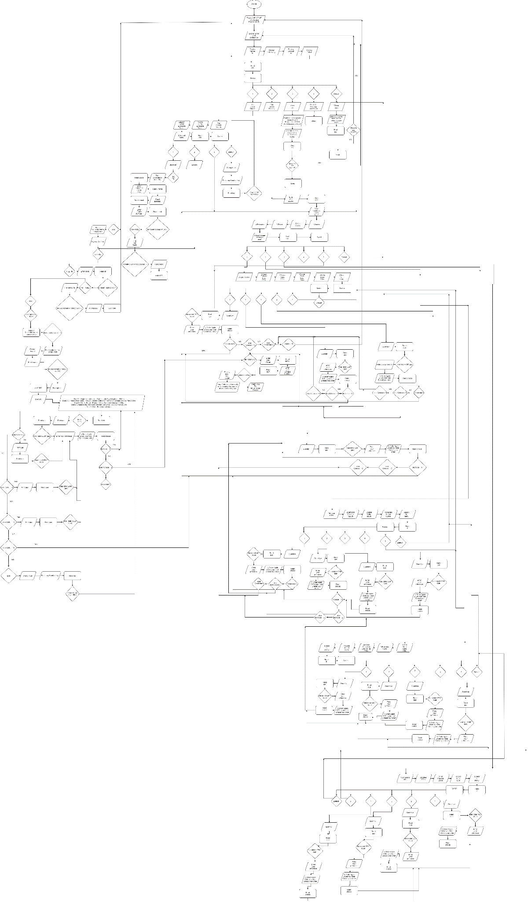

***Chapter 3***

**Working of Project with (Screenshots)**

#include<stdio.h>

#include<stdlib.h>

struct info

{

char code[10];

char name[20];

char email[200];

char mob[20];

}i;

void dine(void);

void delivery(void);

void About(void);

void bio(void);

void adr(void);

void menu(void);

void star(void);

void mainc(void);

void desert(void);

void beverages(void);

void bill(void);

void reset(void);

void treset(void);

void keys(void);

void sign(void);

void login(void);

void deals(void);

char name[100],addr[100];

int total,qua,choice,key,num,wait;

void main(void){

int chk;

system("COLOR 4F");

system("cls");

printf("\t\t\t==================================\n");

printf("\t\t\t|| WELCOME TO LAZEEZ PAKWAAN :D ||\n");

printf("\t\t\t==================================\n");

printf("Enter your preference =>\n");

printf("\t\t\t 1)Dine-In.\n");

printf("\t\t\t 2)Delivery.\n");

printf("\t\t\t 3)About us.\n");

printf("\t\t\t 4)Exit\n");

scanf("%d",&chk);

switch(chk){

case 1:{

printf("You choose Dine-In\n");

printf("\n");

printf("\t\t\t 1)Sign-Up for Exclusive Deals:\n");

printf("\t\t\t 2)Login to Get Exclusive Deals:\n");

printf("\t\t\t 3)Normal Menu:\n");

scanf("%d",&chk);

switch(chk){

case 1:{

printf("SIGN-UP\n");

sign();

login();

break;

}

case 2:{

printf("LOGIN\n");

login();

break;

}

case 3:{

menu();

break;

}

default:{

printf("Wrong Input.\n");

keys();

break;

}

}

break;

}

case 2:{

printf("You choose Delivery\n");

printf("\n");

adr();

printf("Your Address: %s\n",addr);

printf("\n");

printf("\n");

menu();

break;

}

case 3:{

printf("============\n");

printf("||About Us||\n");

printf("============\n");

About();

break;

}

case 4:{

printf("\t\t\t*****************\n");

printf("\t\t\t** **\n");

printf("\t\t\t**Thank You For**\n");

printf("\t\t\t** using our **\n");

printf("\t\t\t** Service **\n");

printf("\t\t\t** **\n");

printf("\t\t\t*****************\n");

break;

}

default:{

printf("Wrong Input\n");

keys();

break;

}

}

}

void menu(void){

int chk;

printf("What would you like to have?\n");

printf("\n");

printf("1)Starters\n");

printf("2)Main Course\n");

printf("3)Desert\n");

printf("4)Beverages \n");

printf("5)Back to home screen and reset?\n");

scanf("%d",&chk);

switch(chk){

case 1:{

printf("\n");

printf("\t\t\t============\n");

printf("\t\t\t||Starters||\n");

printf("\t\t\t============\n");

star();

break;

}

case 2:{

printf("\n");

printf("\t\t\t============\n");

printf("\t\t\t||Main Course||\n");

printf("\t\t\t============\n");

mainc();

break;

}

case 3:{

printf("\n");

printf("\t\t\t============\n");

printf("\t\t\t||Deserts||\n");

printf("\t\t\t============\n");

desert();

break;

}

case 4:{

printf("\n");

printf("\t\t\t============\n");

printf("\t\t\t||Beverages||\n");

printf("\t\t\t============\n");

beverages();

break;

}

case 5:{

reset();

main();

break;

}

default:{

printf("Wrong Input");

keys();

break;

}

}

}

void star(void){

int st;

printf("\n");

printf("1)Finger Fish and Fries 200rs\n");

printf("2)Paneer Tikka 300rs\n");

printf("3)Indian Onion Salad 200rs\n");

printf("4)Garlic Bread 250rs\n");

printf("5)Back to menu\n");

scanf("%d",&st);

switch(st){

case 1:{

printf("Quantity=",qua);

scanf("%d",&qua);

total=total+200*(qua);

printf("Enter your prference:\n");

printf("1) Order Again \t\t\t\t2)Get your total \t\t\t3)reset your order\n");

scanf("%d",&choice);

if(choice==1){

menu();

}

else if(choice==2){

bill();

}

else if(choice==3){

reset();

}

break;

}

case 2:{

printf("Quantity=",qua);

scanf("%d",&qua);

total=total+300*(qua);

printf("Enter your prference:\n");

printf("1) Order Again \t\t\t\t2)Get your total\t\t\t3)reset your order\n");

scanf("%d",&choice);

if(choice==1){

menu();

}

else if(choice==2){

bill();

}

else if(choice==3){

reset();

}

break;

}

case 3:{

printf("Quantity=",qua);

scanf("%d",&qua);

total=total+200*(qua);

printf("Enter your prference:\n");

printf("1) Order Again \t\t\t\t2)Get your total\t\t\t3)reset your order\n");

scanf("%d",&choice);

if(choice==1){

menu();

}

else if(choice==2){

bill();

}

else if(choice==3){

reset();

}

break;

}

case 4:{

printf("Quantity=",qua);

scanf("%d",&qua);

total=total+250*(qua);

printf("Enter your prference:\n");

printf("1) Order Again \t\t\t\t2)Get your total\t\t\t3)reset your order\n");

scanf("%d",&choice);

if(choice==1){

menu();

}

else if(choice==2){

bill();

}

else if(choice==3){

reset();

}

break;

}

case 5:{

menu();

break;

}

default:{

printf("Wrong input.");

keys();

break;

}

}

}

void mainc(void){

int st;

printf("\n");

printf("1)Biryani 400rs\n");

printf("2)Tandoori Chicken 1200rs\n");

printf("3)Malai Kofta 800rs\n");

printf("4)Chicken Kerhai 1000rs\n");

printf("5)Back to menu\n");

scanf("%d",&st);

switch(st){

case 1:{

printf("Quantity=",qua);

scanf("%d",&qua);

total=total+400*(qua);

printf("Enter your prference:\n");

printf("1) Order Again \t\t\t\t2)Get your total\t\t\t3)reset your order\n");

scanf("%d",&choice);

if(choice==1){

menu();

}

else if(choice==2){

bill();

}

else if(choice==3){

reset();

}

break;

}

case 2:{

printf("Quantity=",qua);

scanf("%d",&qua);

total=total+1200*(qua);

printf("Enter your prference:\n");

printf("1) Order Again \t\t\t\t2)Get your total\t\t\t3)reset your order\n");

scanf("%d",&choice);

if(choice==1){

menu();

}

else if(choice==2){

bill();

}

else if(choice==3){

reset();

}

break;

}

case 3:{

printf("Quantity=",qua);

scanf("%d",&qua);

total=total+800*(qua);

printf("Enter your prference:\n");

printf("1) Order Again \t\t\t\t2)Get your total\t\t\t3)reset your order\n");

scanf("%d",&choice);

if(choice==1){

menu();

}

else if(choice==2){

bill();

}

else if(choice==3){

reset();

}

break;

}

case 4:{

printf("Quantity=",qua);

scanf("%d",&qua);

total=total+1000*(qua);

printf("Enter your prference:\n");

printf("1) Order Again \t\t\t\t2)Get your total\t\t\t3)reset your order\n");

scanf("%d",&choice);

if(choice==1){

menu();

}

else if(choice==2){

bill();

}

else if(choice==3){

reset();

}

break;

}

case 5:{

menu();

break;

}

default:{

printf("Wrong input.");

keys();

break;

}

}

}

void desert(void){

int st;

printf("\n");

printf("1)Mint Oreo Cake 400rs\n");

printf("2)Brownies 400rs\n");

printf("3)Molten Chocolate Crackle Pie 550rs\n");

printf("4)Gulab Jamun 300rs\n");

printf("5)Back to menu\n");

scanf("%d",&st);

switch(st){

case 1:{

printf("Quantity=",qua);

scanf("%d",&qua);

total=total+400*(qua);

printf("Enter your prference:\n");

printf("1) Order Again \t\t\t\t2)Get your total\t\t\t3)reset your order\n");

scanf("%d",&choice);

if(choice==1){

menu();

}

else if(choice==2){

bill();

}

else if(choice==3){

reset();

}

break;

}

case 2:{

printf("Quantity=",qua);

scanf("%d",&qua);

total=total+400*(qua);

printf("Enter your prference:\n");

printf("1) Order Again \t\t\t\t2)Get your total\t\t\t3)reset your order\n");

scanf("%d",&choice);

if(choice==1){

menu();

}

else if(choice==2){

bill();

}

else if(choice==3){

reset();

}

break;

}

case 3:{

printf("Quantity=",qua);

scanf("%d",&qua);

total=total+550*(qua);

printf("Enter your prference:\n");

printf("1) Order Again \t\t\t\t2)Get your total\t\t\t3)reset your order\n");

scanf("%d",&choice);

if(choice==1){

menu();

}

else if(choice==2){

bill();

}

else if(choice==3){

reset();

}

break;

}

case 4:{

printf("Quantity=",qua);

scanf("%d",&qua);

total=total+300*(qua);

printf("Enter your prference:\n");

printf("1) Order Again \t\t\t\t2)Get your total\t\t\t3)reset your order\n");

scanf("%d",&choice);

if(choice==1){

menu();

}

else if(choice==2){

bill();

}

else if(choice==3){

reset();

}

break;

}

case 5:{

menu();

break;

}

default:{

printf("Wrong input.");

keys();

break;

}

}

}

void beverages(void){

int st;

printf("\n");

printf("1)Lamonade 100rs\n");

printf("2)Coffee 200rs\n");

printf("3)Hot Choclate 250rs\n");

printf("4)Cold Drinks 80rs\n");

printf("5)Back to menu\n");

scanf("%d",&st);

switch(st){

case 1:{

printf("Quantity=",qua);

scanf("%d",&qua);

total=total+100*(qua);

printf("Enter your prference:\n");

printf("1) Order Again \t\t\t\t2)Get your total\t\t\t3)reset your order\n");

scanf("%d",&choice);

if(choice==1){

menu();

}

else if(choice==2){

bill();

}

else if(choice==3){

reset();

}

break;

}

case 2:{

printf("Quantity=",qua);

scanf("%d",&qua);

total=total+200*(qua);

printf("Enter your prference:\n");

printf("1) Order Again \t\t\t\t2)Get your total\t\t\t3)reset your order\n");

scanf("%d",&choice);

if(choice==1){

menu();

}

else if(choice==2){

bill();

}

else if(choice==3){

reset();

}

break;

}

case 3:{

printf("Quantity=",qua);

scanf("%d",&qua);

total=total+250*(qua);

printf("Enter your prference:\n");

printf("1) Order Again \t\t\t\t2)Get your total\t\t\t3)reset your order\n");

scanf("%d",&choice);

if(choice==1){

menu();

}

else if(choice==2){

bill();

}

else if(choice==3){

reset();

}

break;

}

case 4:{

printf("Quantity=",qua);

scanf("%d",&qua);

total=total+80*(qua);

printf("Enter your prference:\n");

printf("1) Order Again \t\t\t\t2)Get your total\t\t\t3)reset your order\n");

scanf("%d",&choice);

if(choice==1){

menu();

}

else if(choice==2){

bill();

}

else if(choice==3){

reset();

}

break;

}

case 5:{

menu();

break;

}

default:{

printf("Wrong input.");

keys();

break;

}

}

}

void bill(void){

float gtotal,tax;

tax=total*0.16;

bio();

printf("\n\n");

gtotal=total+tax;

printf("\t\t\tTotal Amount=%d\n\n\n",total);

printf("\t\t\tGST=%.2f\n\n\n",tax);

printf("\t\t\tTotal Amount to pay:%.2f\n\n\n",gtotal);

printf("%s Your Order would be ready in 40 minutes,Pay your bill at counter/delivery guy.\n\n\n",name);

printf("\t\t\t*****************\n");

printf("\t\t\t** **\n");

printf("\t\t\t**Thank You For**\n");

printf("\t\t\t**for using our**\n");

printf("\t\t\t** Service **\n");

printf("\t\t\t** **\n");

printf("\t\t\t*****************\n");

}

void About(void){

system("cls");

printf("People behind the project:\n\n\n -->Aman-2012375\n\n -->Hasnain Ali-2012384\n\n -->Ali Mohammad-2012389\n\n ");

keys();

}

void reset(void){

total=total*0;

main();

}

void treset(void){

total=total*0;

deals();

}

void bio(void){

printf("Enter your name:");

scanf(" %[^\n]%*c",name);

printf("Enter your Contact Number:");

scanf("%d",&num);

}

void adr(void){

printf("Enter your address:\n");

scanf(" %[^\n]%*c",addr);

}

void keys(void){

int key;

printf("\nPress any Number key:\n");

scanf("%d",&key);

if(key>=0 && key<=999){

main();

}

}

void sign(void){

FILE *fp;

struct info;

printf("Enter Code(alpha-numeric):");

scanf(" %s",&i.code);

printf("Enter name(first name only):");

scanf(" %s",&i.name);

printf("Email address:");

scanf(" %s",&i.email);

printf("Enter mobile number:");

fflush(stdin);

gets(i.mob);

fp=fopen("signup.txt","a");

if(fp==NULL){

printf("File not found");

for(wait=0;wait<=100000;wait++)

{

printf("\rIn progress : %d",wait/1000);

}

}

else{

fprintf(fp,"%s %s %s %s \n",i.code,i.name,i.email,i.mob);

printf("Sign-up Confirm.");

}

printf("\n");

fclose(fp);

}

void login(void){

int wait;

struct info;

FILE *fp;

char ch[5];

printf("Enter code:");

scanf(" %s",&ch);

fp=fopen("signup.txt","r");

if(fp==NULL){

printf("File not found");

for(wait=0;wait<=100000;wait++)

{

printf("\rIn progress : %d",wait/1000);

}

main();

}

else{

while(getc(fp) != EOF){

fscanf(fp,"%s %s %s %s",&i.code,&i.name,&i.email,&i.mob);

if(strcmp(ch,i.code)==0){

printf("%s %s %s %s",i.code,i.name,i.email,i.mob);

printf("\nRecord Found\n");

printf("Name: %s\n",i.name);

printf("\n");

for(wait=0;wait<=100000;wait++)

{

printf("\rIn progress : %d",wait/1000);

}

printf("\n\n");

deals();

break;

}

}

}

fclose(fp);

printf("Record not Found.\n");

keys();

}

void deals(void){

int chk,key;

system("cls");

printf("\t\t\t=========\n");

printf("\t\t\t||DEALS||\n");

printf("\t\t\t=========\n");

printf("Deal 1: 1 finger fish and fries, 2 karhai , and 1 gulab jamun= 2500rs\n");

printf("Deal 2: 2 Indian Onion Salad, 1Biryani, 2Malai Kofta and 1 Molten Chocolate Crackle Pie= 2600rs\n");

printf("Deal 3: 2Garlic Bread, 1Paneer Tikka, 1Tandoori Chicken= 2000rs\n");

printf("Deal 4: 2Malai Kofta, 1Tandoori Chicken,3Brownies, 3Cold Drink= 4000rs\n");

printf("Deal 5: Order From normal menu\n");

scanf("%d",&chk);

if(chk == 1){

printf("Quantity=",qua);

scanf("%d",&qua);

total=total+2500*(qua);

printf("Enter your prference:\n");

printf("1) Order Again \t\t\t\t2)Get your total\t\t\t3)reset your order\n");

scanf("%d",&choice);

if(choice==1){

deals();

}

else if(choice==2){

bill();

}

else if(choice==3){

treset();

}

}

else if(chk == 2){

printf("Quantity=",qua);

scanf("%d",&qua);

total=total+2600*(qua);

printf("Enter your prference:\n");

printf("1) Order Again \t\t\t\t2)Get your total\t\t\t3)reset your order\n");

scanf("%d",&choice);

if(choice==1){

deals();

}

else if(choice==2){

bill();

}

else if(choice==3){

treset();

}

}

else if(chk == 3){

printf("Quantity=",qua);

scanf("%d",&qua);

total=total+2000*(qua);

printf("Enter your prference:\n");

printf("1) Order Again \t\t\t\t2)Get your total\t\t\t3)reset your order\n");

scanf("%d",&choice);

if(choice==1){

deals();

}

else if(choice==2){

bill();

}

else if(choice==3){

treset();

}

}

else if(chk == 4){

printf("Quantity=",qua);

scanf("%d",&qua);

total=total+4000*(qua);

printf("Enter your prference:\n");

printf("1) Order Again \t\t\t\t2)Get your total\t\t\t3)reset your order\n");

scanf("%d",&choice);

if(choice==1){

deals();

}

else if(choice==2){

bill();

}

else if(choice==3){

treset();

}

}

else if(chk == 5){

menu();

}

else{

printf("wrong input\n");

printf("\nPress any Number key:\n");

scanf("%d",&key);

if(key>=0 && key<=999){

deals();

}

}

}

***(Screenshots)***

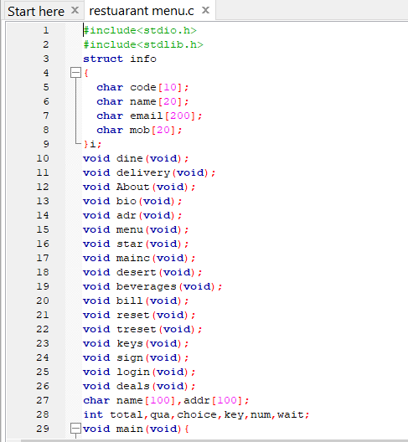

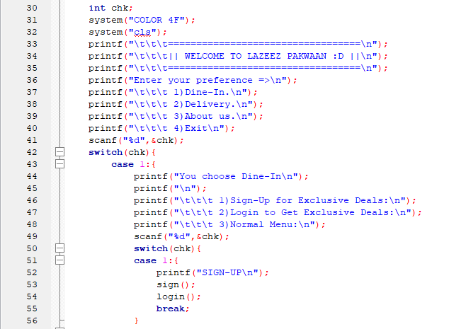

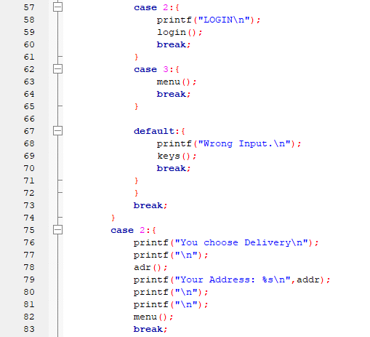

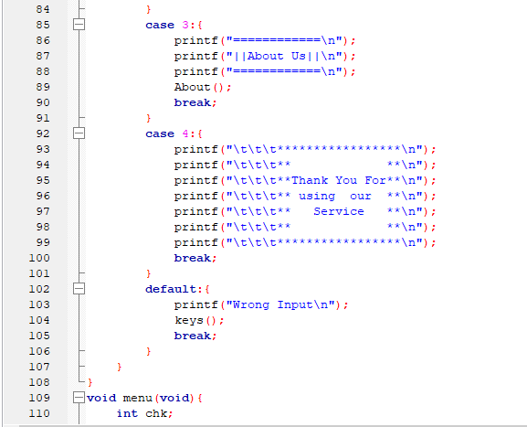

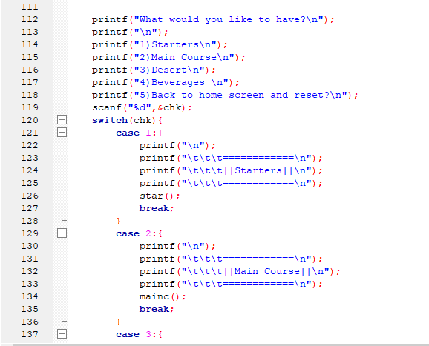

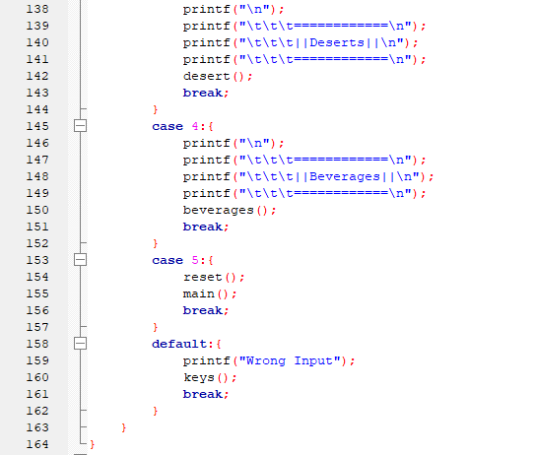

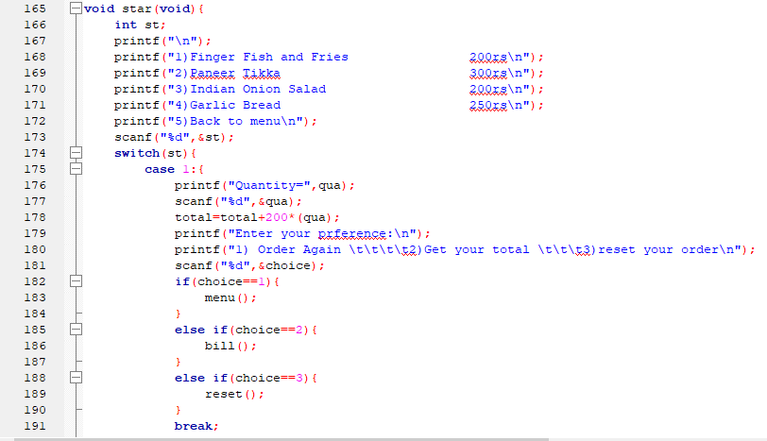

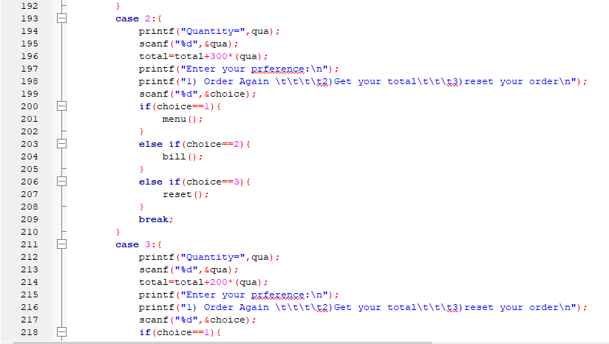

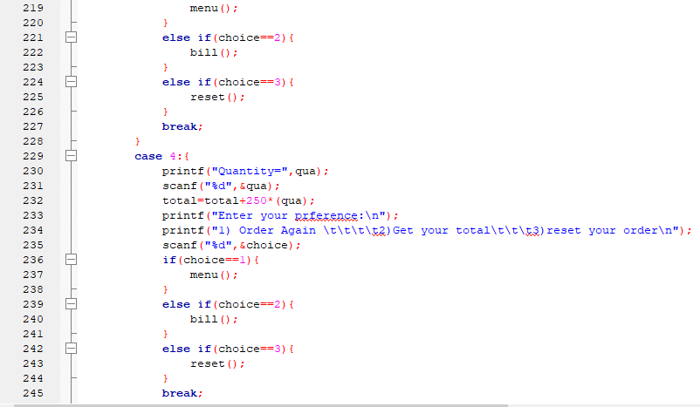

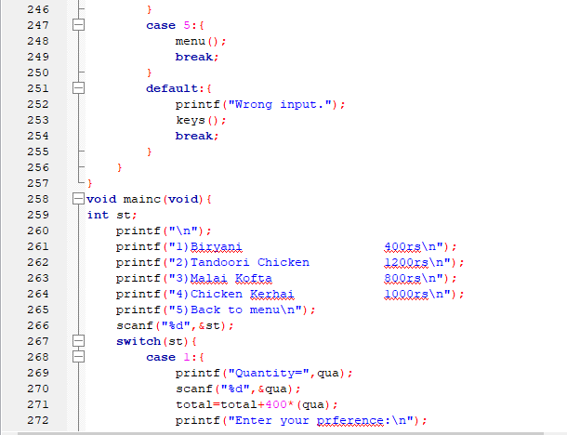

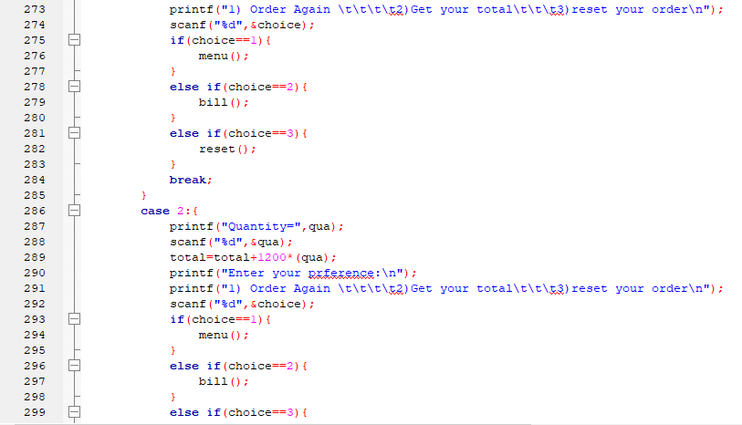

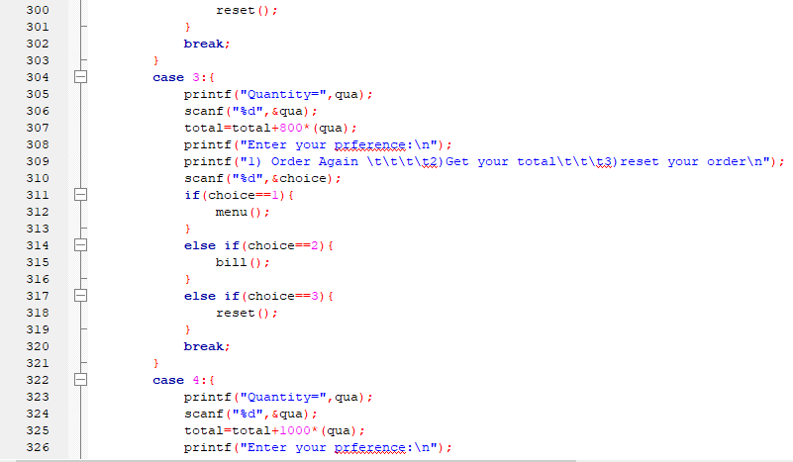

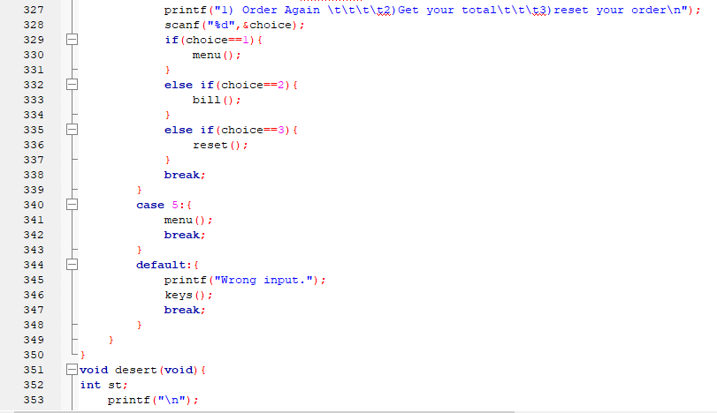

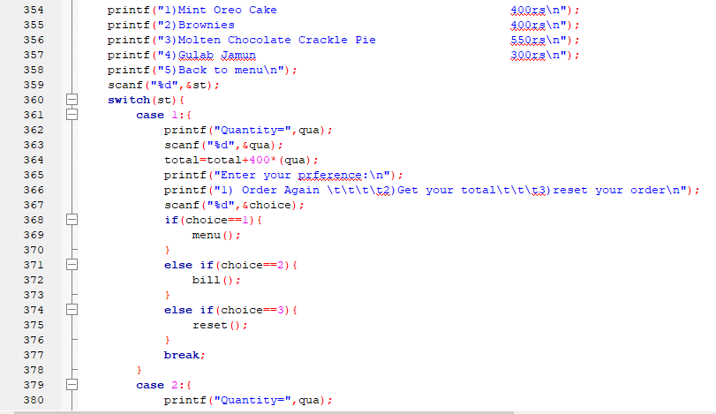

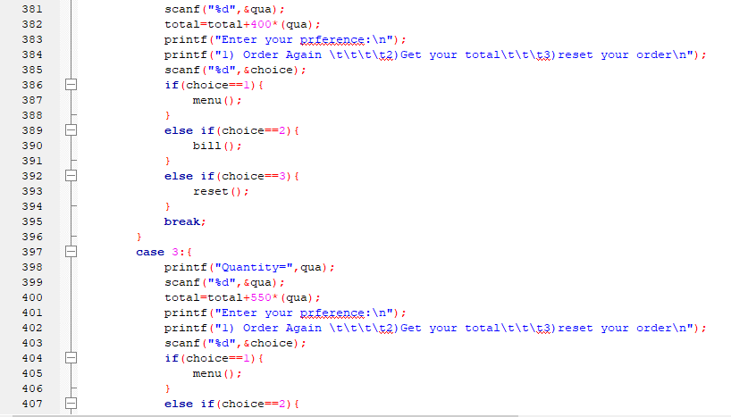

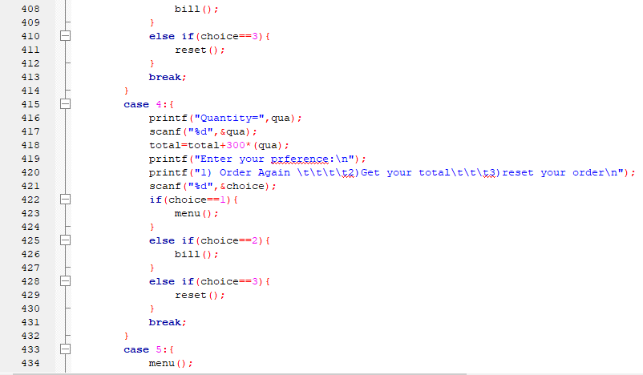

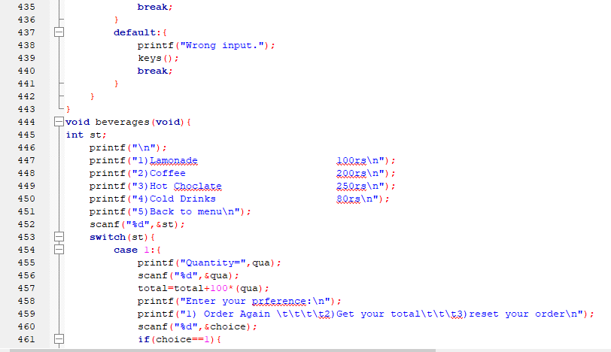

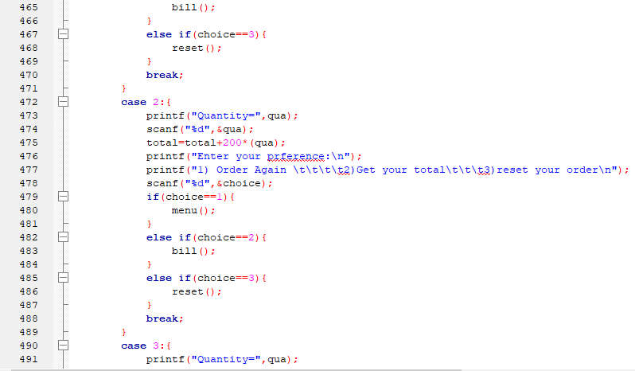

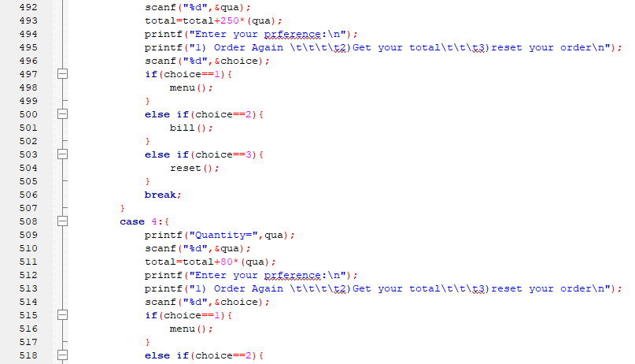

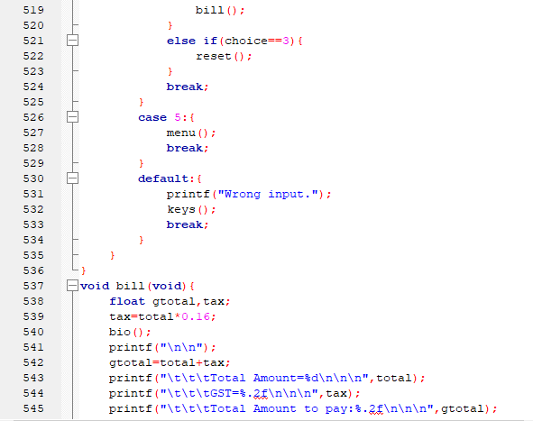

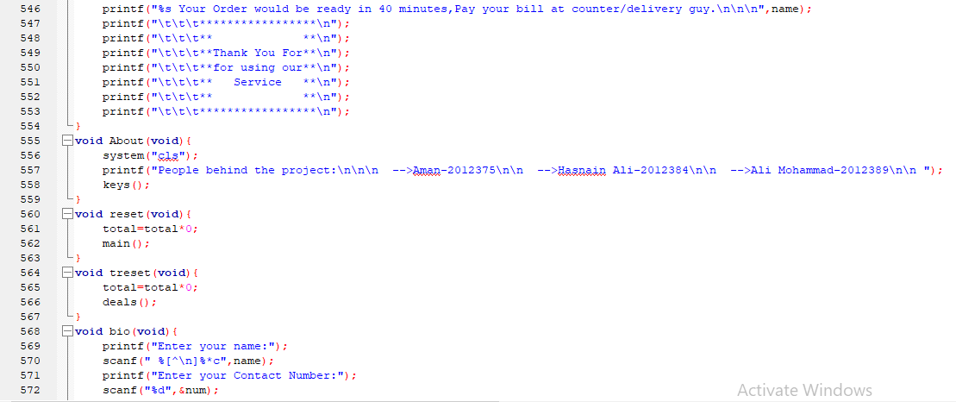

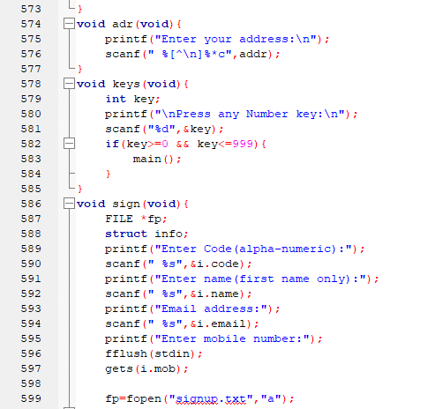

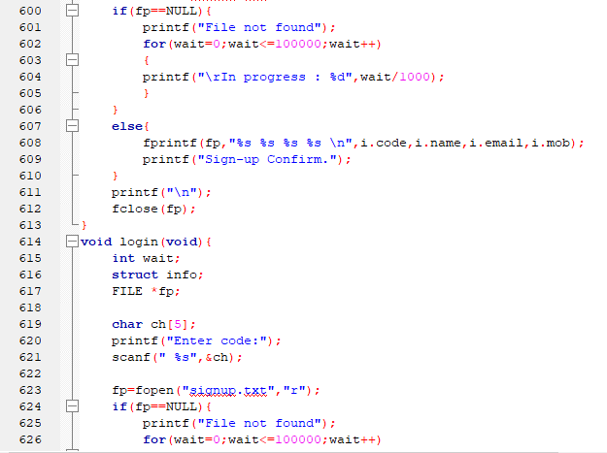

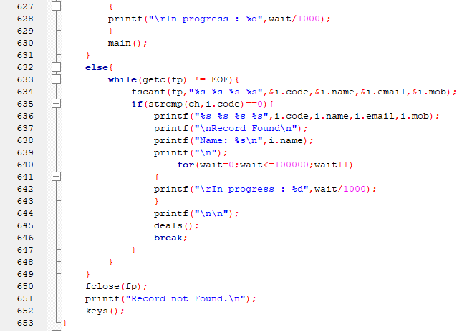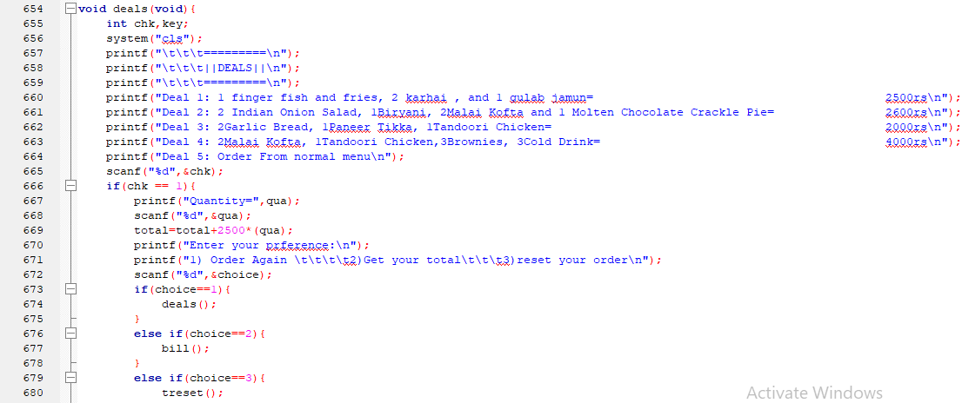

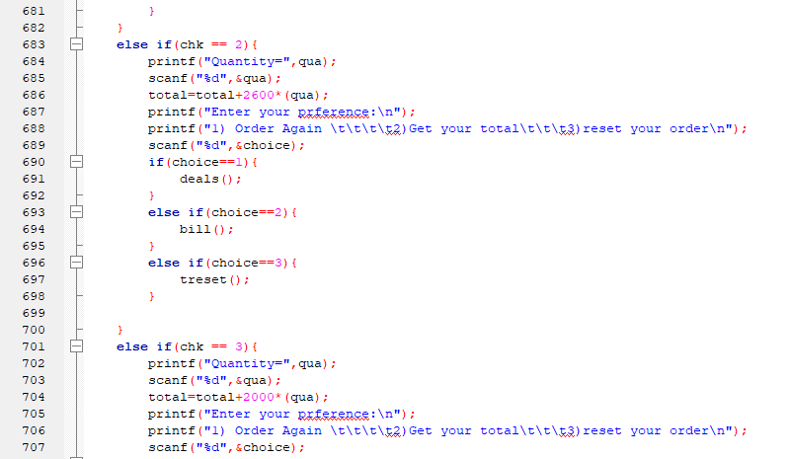

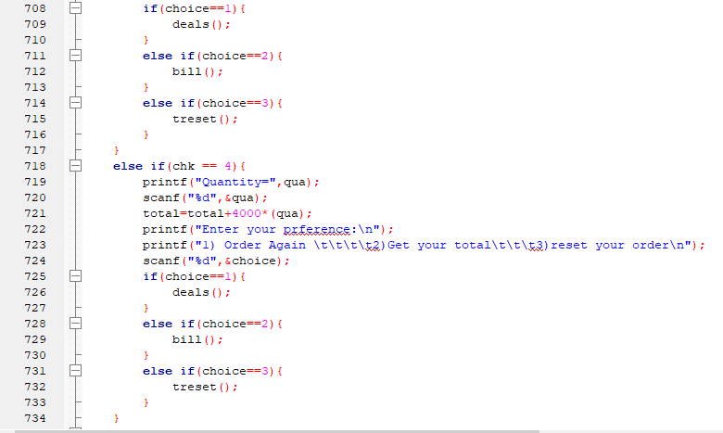

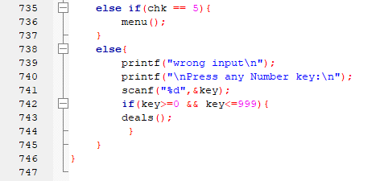

***(Output)***

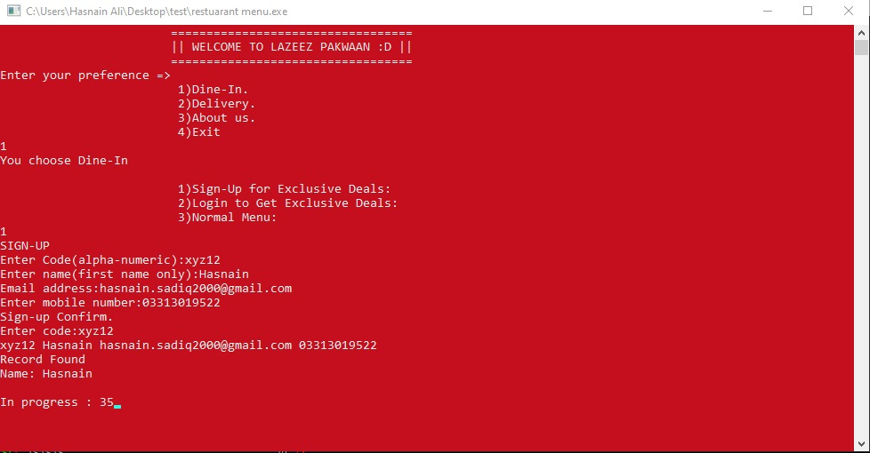

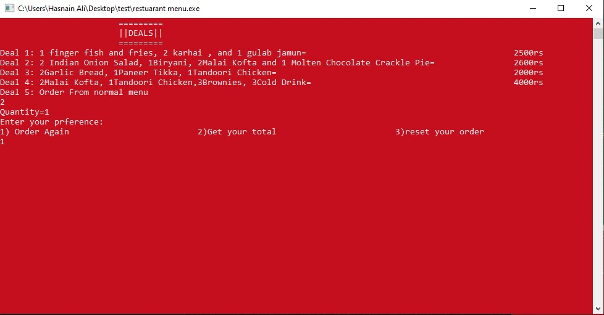

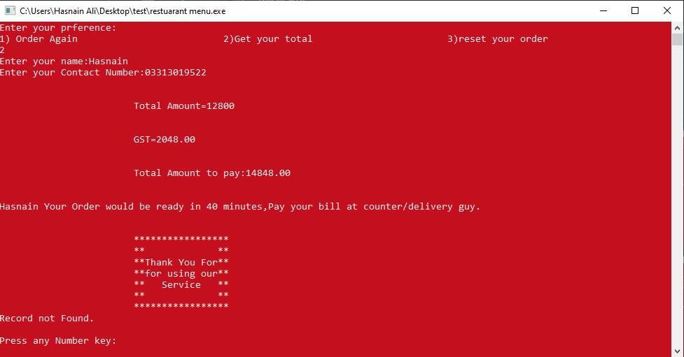

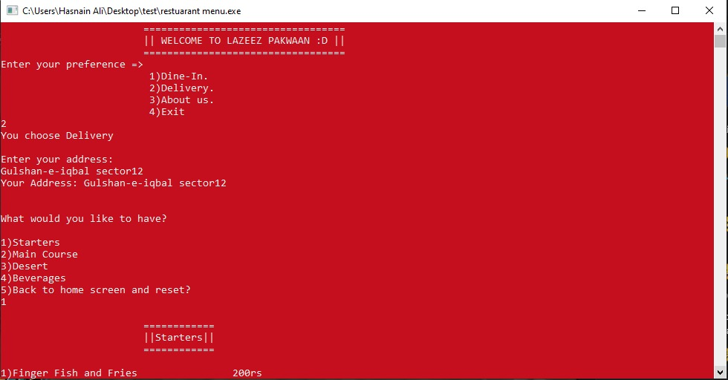

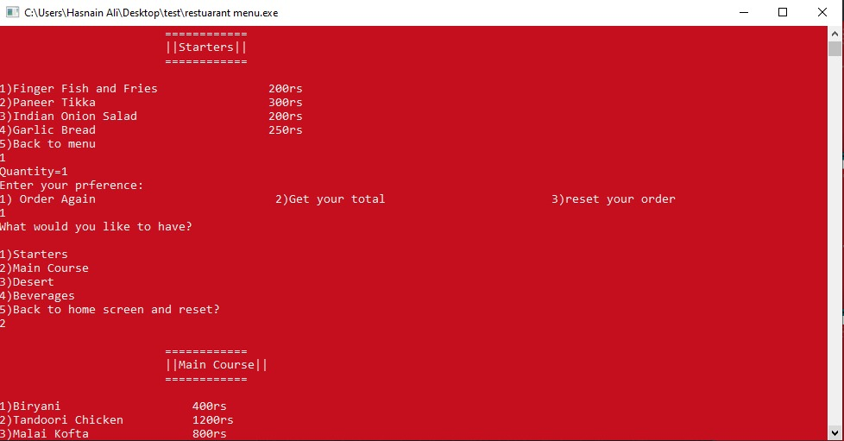

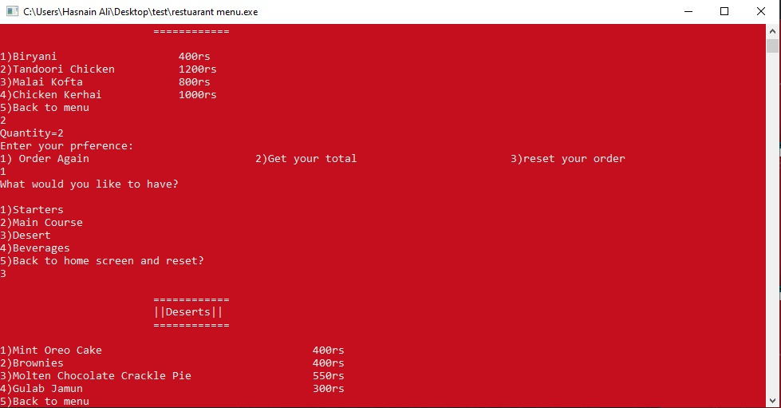

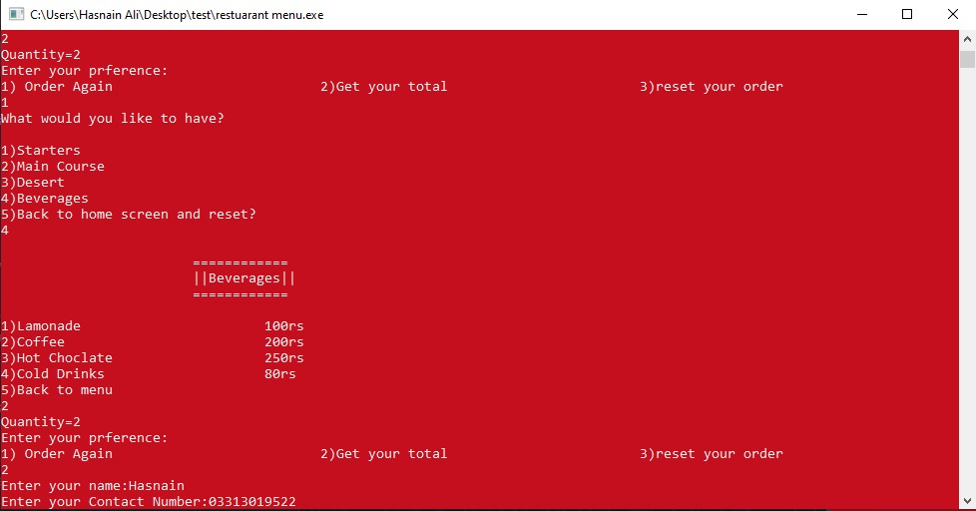

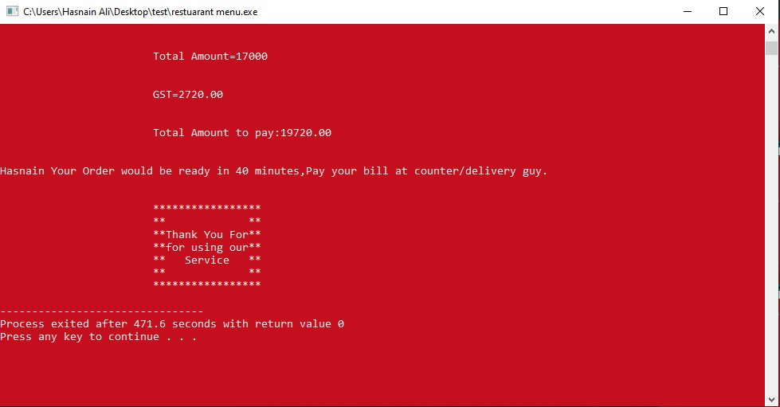

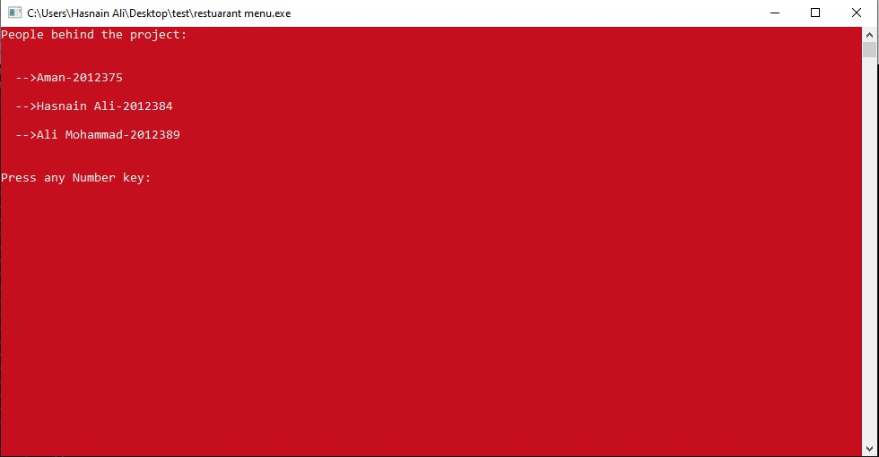

***Chapter 4***

***Background and Problems***

This Case study looks at the problem of setting up a restaurant menu system. In existing system there is problem:

* + - * Restaurant needs certain employees to take the order over phone or in-person, to offer a rich dining experience and process the payment. In today’s market, labor rates are increasing day by day making it difficult to find employees when needed.
      * This program also has a problem in filing as it does not take the input of the first record so we store the garbage value which is used to be ignored by the compiler.

The main advantage of our system is that it greatly simplifies the ordering process for both the customer and the restaurant and also greatly lightens the load on the restaurant’s end.

* + - 1. This will minimize the number of employees at the back of the counter.
      2. The system will help to reduce waiter cost involved.
      3. The system will be less probable to make mistake, since it’s a machine.
      4. This will avoid no long queues at the counter.

***Chapter 5***

***Conclusion***

The proposed restaurant menu system is time saving and error free as compared to the traditional system. This system attracts customers and also adds the efficiency of maintaining the restaurant’s ordering and billing. To the restaurant owner this digital system helps them minimize the workload. Home delivery system is available. Once the order will be done then the user will edit or reset their order.